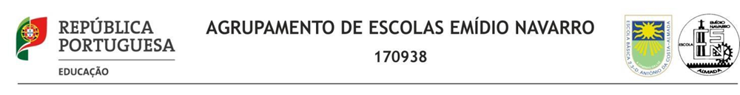
Erasmus + "I am not a target” 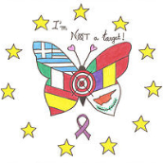
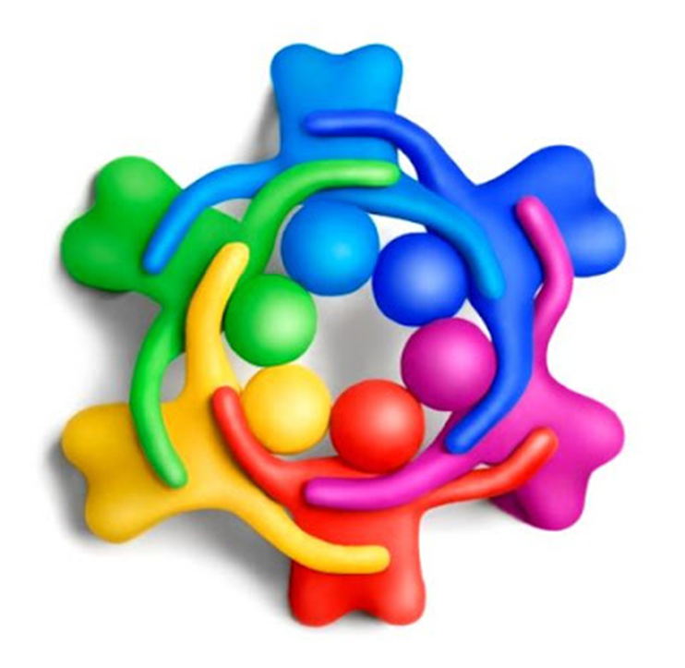
Educational Project
"THE VALUES"
March 2020

Project elaborated by
Teachers of EB da Cova da Piedade

Educational Project
"The values"
March 2020
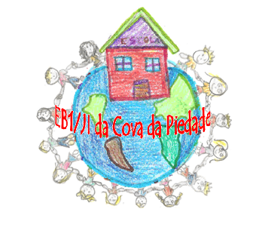

Escola Básica da Cova da Piedade
AE Emídio Navarro
Cova da Piedade/Almada

- Argument
In recent years we have seen a changing society and there are several factors that originate these transformations. We are witnessing the gradual technological and scientific advancement, the increasing ease of access to knowledge and the expansion of the means of communication and information.
However, not everything is an advantage: the rate of poverty, inequality, violence, intolerance, environmental problems and conflicts are increasingly present in everyday life.
Education is one of the pillars of society that must contribute to the integral formation of children and young people, as such, given the current requirements, it is necessary to pay attention to the moral and civic education of individuals, who will be the citizens of the future. It is necessary to alert them to certain values ​​that help them to face and improve their social future, as well as their personal and professional future.
Here comes the fundamental role of the school as a context that prepares the human being - student - to understand and value the different types of information, opportunities, situations and materials that he will encounter in his daily life, in different contexts.
This project seeks to understand how it is possible to promote an education of values ​​in the Pre – School and 1st cycle of basic education, in different subjects. Its objectives are to develop social skills in different contexts and situations.
It also seeks to understand how the development of meaningful and functional learning can contribute to students' social maturity.
The implementation of this project allowed us to understand that the contact with everyday materials can contribute to increase the capacities and knowledge of students, at the level of their conscience as a citizen, who lives in society, giving meaning to their learning.
It is also possible to perceive that these same materials make them aware of certain values, making them builders of their knowledge, making them develop their skills and social maturity.

- Objectives of the project
It is a project that aims to support the school and the family in the education of children, at the level of knowing how to be, motivating them to discover and deepen the fundamental values ​​of conduct and life in society.
Values ​​directly influence the behaviors and attitudes of children and young people, perpetuating models and guaranteeing social balance, so the issue of values ​​is a priority in European education policy.
Expressions assume, in the scope of the project, an important role, sensitizing children to a deeper knowledge of the values ​​and their implications in their daily lives and in the successes they dream for their future.

- Target Group
Pre-school and 1st cycle (4/10 years old)

- Direct and indirect beneficiaries
Direct: Students, teachers, parents.
Indirect: The community

- Duration of the Project:
March 2020

- Place of Performance:
Classrooms, Library, Gym and Schoolyard.

- Special Participation:
“KidFun -“ Education for Values ”- Benfica Foundation which aims to support the school and the family.

- Materials:
Television, placards, physical education material, cardboards, markers, thematic videos, interactive board…

- Activities
 | Activities | Place | Term
1 | -View the film “Brave”.  (Knowing how to take responsibility) | Classroom / library | march 2020  Week 1
2 | -Dialogue with students about values.  -Development of a panel referring to the theme “Grow with value”. | Classroom | march 2020  Week 2
3 | - Videos about public figures that appeal to values. | Library | march 2020  Week 2
4 | - Cooperative games for pairs / groups. | Gymnasium | march 2020  Week 2
5 | - “Pass the secret” - phrases alluding to values passed from ear to ear. | School classroom / courtyard | march 2020  Week 3
6 | - Debates- talk about humility and respect | Classroom | march 2020  Week 4

- Conclusion
First of all, it is necessary to reinforce that bullying is not normal, it is not part of “being a child” or “growing up”, it does not make children “stronger”. Before talking to children about bullying it is important that parents know this reality without misrepresenting it. It is also very important not to forget the values ​​in the child's education, as well as the transmission of good practices, knowing how to be, knowing how to listen and knowing how to act in accordance with situations without generating violence.
It is not only necessary to have someone who speaks and transmits the education of values, but it is essential that it be included in any other subject.
Just as it would be important for this type of education to be present in all households and in society in general.
The education of values ​​must be centered on fostering a critical spirit, on highlighting equal opportunities, on being tolerant and responsible.
This is the path that we are slowly trying to help build. A school that records in the memory of our students the values, differences, respect for inclusion and the right to exercise interventional citizenship.
With this project the school will consolidate its mission, overcoming challenges and constraints, and betting on its feasibility.

